01 — Department Overview
The dual mandate: internal enabler and external showcase.
The Information Technology Department serves as the digital backbone of CPN and a living demonstration of professional standards in practice. Internally, we architect, secure, and operate all systems that power registration, licensing, verification, and council operations nationwide. Externally, we are a showcase — our portal, data governance, and cybersecurity posture must exemplify what it means to be a chartered IT professional in Nigeria.
We operate on a product mindset with government-grade reliability: agile delivery, audited controls, and citizen-centric design. Every system we ship reinforces public trust in the computing profession.
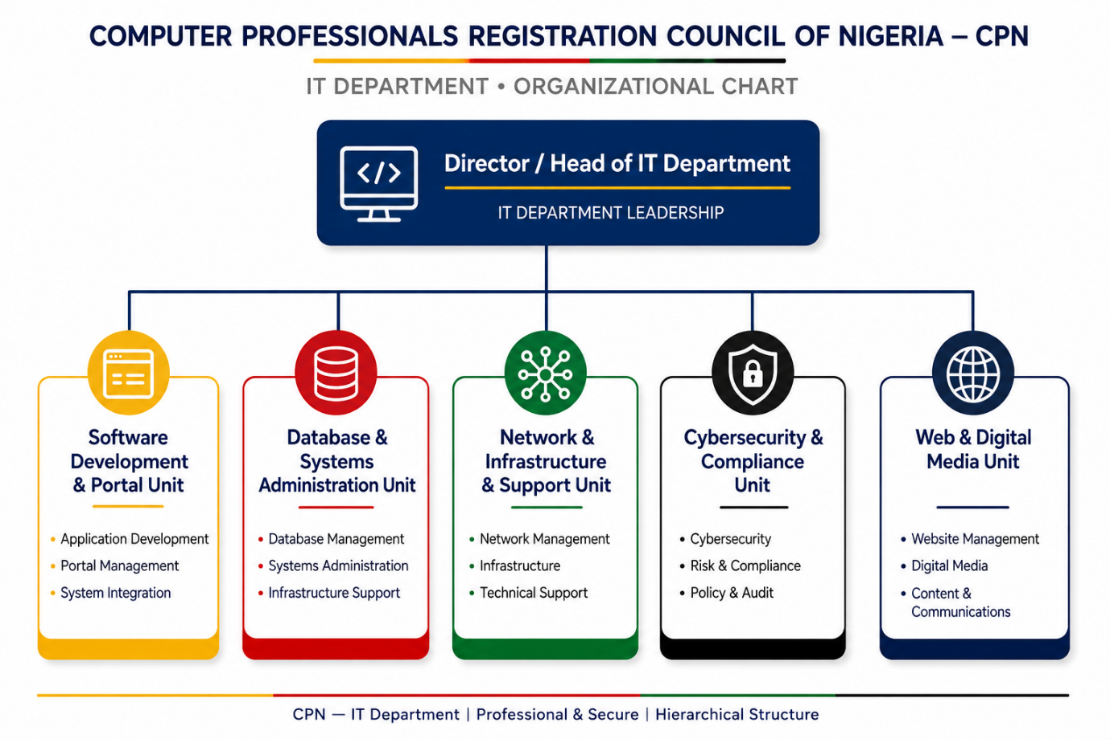

02 — Organizational Structure
The IT Department is structured to ensure specialization, accountability and 24/7 availability of critical regulatory systems. The organogram above reflects a lean but effective structure suitable for CPN Headquarters and liaison with Zonal Offices.

03 — Vision, Mission and Strategic Objectives
- Vision: To be a world-class IT Department that powers CPN as a fully digital, secure, and transparent regulator of IT practice in Nigeria.
- Mission: To deploy, manage and secure robust, innovative and compliant technology solutions that enable efficient regulation, excellent service delivery to members and the public, and evidence-based decision making.

Strategic Objectives:
- Digitize 100% of core regulatory processes (Registration, Licensing, Renewal, Verification, Accreditation, CPD) within 12-18 months.
- Ensure 99.9% uptime of all public-facing platforms (Portal, Verification, Payment).
- Establish a single source of truth - a National Database of IT Professionals, Firms and Accredited Institutions.
- Achieve compliance with NDPA 2023, NITDA Frameworks, and ISO 27001 principles.
- Reduce manual processing time for registration/renewal from weeks to less than 72 hours.
- Provide data analytics and dashboards for Management and Council.
- Position CPN as a model for digital government through paperless operations.

04 — Detailed Functions

A. Software Development & Portal Management Unit
Responsible for all in-house and outsourced software. Manages CPN portal, online registration & renewal, e-payment integration with Remita/Interswitch, verification portal, CPN exam/induction/CPD system, AGM portal. Ensures UI/UX, documentation and UAT.

B. Database & Systems Administration Unit
Custodian of all CPN databases. Manages SQL Server/PostgreSQL for Members, Firms, Institutions. Backup & DR, integrity, de-duplication, performance tuning, statutory reports. Maintains Galaxy Backbone/cloud link.

C. Network, Infrastructure & Technical Support Unit
Manages LAN/WAN/WiFi, PABX, ISPs, servers, storage, UPS, data centre. IT procurement specs, asset inventory, helpdesk (L1 & L2), IPPIS, email system, virtual meetings.

D. Cybersecurity & Compliance Unit
Develops and enforces InfoSec Policy, Acceptable Use, Data Protection. Implements firewall, WAF, EDR, MFA, PAM. Quarterly VA, awareness, incident response, NDPA/NITDA compliance.

E. Web, Digital Communications & Multimedia Unit
Manages website content, social media, newsletters, multimedia for induction, IT Assembly, live streaming, branding.

